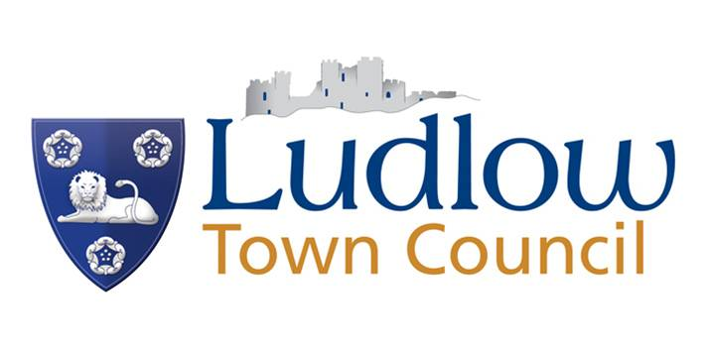

CIVIC AWARDS CRITERIA

There are three awards:
- for people over 18 - Civic Award
- for people under 18 - Young Persons’ Civic Award
- Community Group –Civic Award

- Nominees should have:

  - Made a material contribution to the advancement, well being and welfare of the people of Ludlow: or
  - Demonstrated outstanding citizenship: or
  - Carried out unpaid work in the community for some time: or
  - Through their endeavours put Ludlow on the map: or
  - Through their contribution made Ludlow a better place to live

- No nominations will be put forward or initiated by Members or current staff.

- Any nominations considered must have been proposed and seconded by residents within the Ludlow Parish Boundary and / or appear in the electoral register for Ludlow.

- Members of the Council may in their private capacity nominate individuals.

- No nomination be considered in respect of any sitting Town, Unitary Councillors or serving employees. However past Councillors and employees are eligible.

- Each valid nomination be considered on its own merits and no firm criteria be specified.

- Each nomination will need to be accompanied by a citation setting out the reasons why they have been nominated.

- The Civic award will comprise of a framed A4 certificate on high quality paper and include the words “in recognition of outstanding service to the people of Ludlow on whose behalf Ludlow Town Council records its appreciation”.

- Nominations will be invited in March every year through the local press, posters, notice boards, website and social media.

- All nominations must be received with all relevant accompaniments by the date on the form so that they can go onto the Full Council Agenda. Those received after that time and date will not be eligible for consideration.

- Successful nominees will be notified in writing and invited to attend Mayor Making for presentation of the Civic Award.

- The presentation of all Civic Awards will be made at the Mayor Making ceremony held every May and the Award will be presented by the newly elected Town Mayor.

